***i****ntelligent* **R**evenue **E**nhancement and **P**rotection **S**olution

*i*REPS

by F Kentane

ireps bible v0.1 230601

Short Table of Contents

1 Introduction 6

2 What is iREPS 6

3 What inspired iREPS 6

4 The Energy paradigm in SA 6

5 The Problem Space - Challenges 6

6 Solutions – iREPS 7

7 iREPS Philosophy 7

8 iREPS architecture 7

9 iREPS users 8

10 iREPS Key Data Components 8

11 iREPS user interface 9

12 Partner Network 9

13 iREPS Development Strategy and Sustainability over time 9

14 Why would you want to use iREPS 10

15 Appendix 10

Table of Contents

1 Introduction 6

2 What is iREPS 6

3 What inspired iREPS 6

4 The Energy paradigm in SA 6

5 The Problem Space - Challenges 6

5.1 Local gov revenue model 6

5.2 The Energy Distribution Network Problems 6

5.3 Billing System at local gov level 6

5.4 Revenue Collection 6

5.5 Eskom Billing at local gov 6

6 Solutions – iREPS 7

6.1 The HR 7

6.2 The Processes 7

6.3 The Technology 7

7 iREPS Philosophy 7

7.1 Best User Experience 7

7.2 Latest Web Technologies 7

7.3 Sustainability 7

7.4 Give back to community 7

8 iREPS architecture 7

8.1 The Client Systems 7

8.2 The Server Systems 8

8.3 iREPS Technologies 8

8.4 Built-in Security 8

9 iREPS users 8

9.1 User Roles 8

9.1.1 Trial User 8

9.1.2 Full user 8

9.2 Municipal Customers 8

10 iREPS Key Data Components 8

10.1 Cadastral data 8

10.2 Deeds Office Data 8

10.3 Field Data 8

10.3.1 Automatically Acquired Field Data 8

10.3.2 User Acquired Field Data 8

11 iREPS user interface 9

11.1 Authentication System 9

11.2 Assets 9

11.3 Transactions 9

11.4 Dashboard 9

11.5 Supply Chain 9

11.6 Cadastral Data Management 9

11.7 iREPS Body of Knowledge 9

11.8 Admin 9

12 Partner Network 9

12.1 Energy Network Assets Partners 9

12.2 Electricity Vending Partners 9

12.3 Academic Institutions 9

13 iREPS Development Strategy and Sustainability over time 9

14 Why would you want to use iREPS 10

14.1 Data Cleansing 10

14.2 Manage and Track Assets 10

14.3 Enhance and Optimize Revenue Collection 10

14.4 Electricity Vending 10

14.5 Manage and Prevent Meter Tempering 10

14.6 Debt Collection 10

14.7 Electronic Municipal Invoice Delivery 10

14.8 Remit Municipal Bills/Invoices 10

14.9 Credit Control 10

14.10 Instant Access to iREPS data 10

15 Appendix 10

15.1 Data dictionary 10

# Introduction

# What is iREPS

# What inspired iREPS

# The Energy paradigm in SA

# The Problem Space - Challenges

## Local gov revenue model

## The Energy Distribution Network Problems

## Billing System at local gov level

## Revenue Collection

## Eskom Billing at local gov

# Solutions – iREPS

Solution strategy – Three pillars

## The HR

## The Processes

## The Technology

# iREPS Philosophy

## Best User Experience

Material UI

## Latest Web Technologies

Google Analytics

Artificial Intelligence

Machine Learning

## Sustainability

## Give back to community

# iREPS architecture

## The Client Systems

## The Server Systems

## iREPS Technologies

## Built-in Security

# iREPS users

## User Roles

### Trial User

### Full user

#### Super User

#### Manager Roles

#### Supervisor

#### Field Worker

## Municipal Customers

# iREPS Key Data Components

## Cadastral data

## Deeds Office Data

## Field Data

#### ast data – common attributes

1. **ast category**: This is includes only meter, cb, seal, box, pole.
2. **ast no**: This is the number allocated to an ast
3. **ast serial no**:
4. **ast state**: This indicates the state of the ast and is limited to ‘**stores’**, ‘**checked out’**, ‘**field’**, ‘**service’**

#### ast data – specific attributes

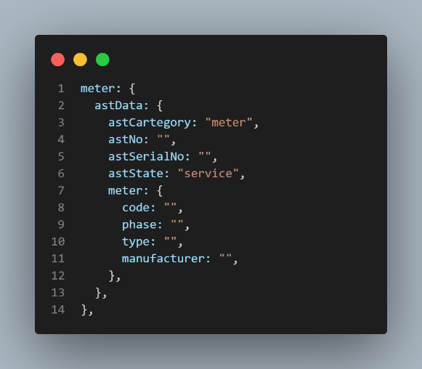**m**eter:

1. meter.code:
2. meter.type:
3. meter.phase:
4. meter.manufacturer:

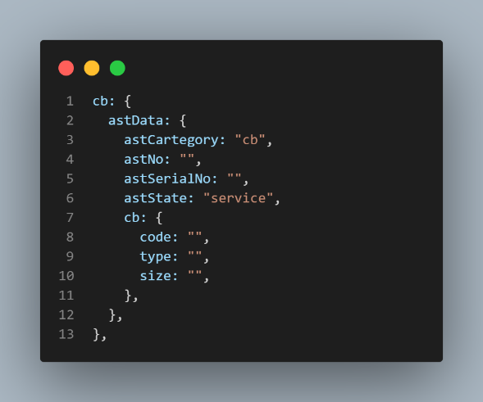**c**b:

1. cb.code:
2. cb.type:
3. cb.size:

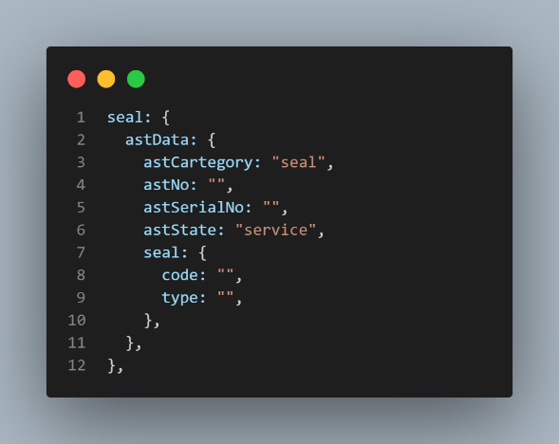**s**eal:

1. seal.code:
2. seal.type:

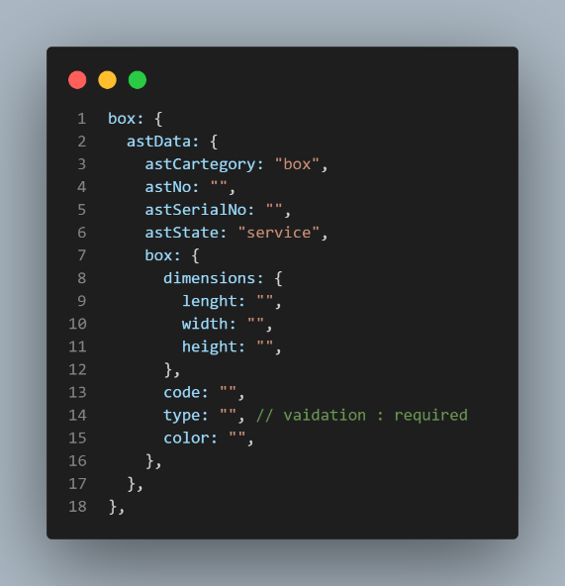**b**ox:

1. box.dimensions:

1.1) length:

1.2) width:

1.3) height:

1. box.code:
2. box.type:
3. box.color:

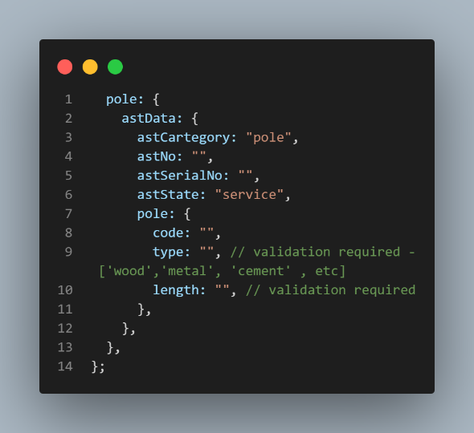pole:

1. pole.code:
2. pole.type:
3. pole.length:

### Automatically Acquired Field Data

### User Acquired Field Data

# iREPS user interface

Interfaces describe what the user sees so as to be able to interact with iREPS. The table below shows summary of all high level interfaces (ones that are available for menu level 1 (ml1)).

## Menu System

iREPS is a menu driven enterprise application. This means access to any functionality in the system is via a menu. Below is a tree showing menu system.

The menu system is characterized by different levels on which a particular menu belongs to. Menu Level 1 (ml1) is the highest-level menu. All key functionality is found at this level.

### Assets Menu Level 1 and Level 2 Functionality

Click on ASTS: display a **table** of all iREPS assets (meters, circuit breakers, seals, boxes and poles)

* Click on ASTS menu button > METERS: display **table** of only **meters**
* Click on ASTS menu button > CB: display **table** of only **circuit breakers**
* Click on ASTS menu button > SEAL: display **table** of only **seals**
* Click on ASTS menu button > BOXES: display **table** of only **boxes**
* Click on ASTS menu button > POLES: display **table** of only **poles**

### Assets Table Page Menus

The rows in a table have menu buttons in some of the columns and the list below indicates the outcomes of a click on a menu button.

* Click on EDIT ast > display asset edit form (astForm)

## Authentication System

## Assets

#### The Tabular View – iREPS Assets Table

#### The Spatial view – iREPS Assets Map

#### The Hierarchical View – iREPS Assets Tree

## Transactions

## Service Connections - scnc

All scns are listed in a collection called scnc.

#### The Tabular View – scns Table

Columns

Col1: Created by

Col2: Created At Datetime

Col13: Updated by

Col4: Updated At Datetime

Col5: Transformer No

Col6: Feeder No

Col7: Scns No

Col7.1: Box No

Col7.1.1: Circuit Breaker

Col7.1.2 Meter No

Col7.1.3.Seal No

Col7.2: Erf No

Col7.2.1: Circuit Breaker

Col7.2.2: Meter No

Col7.2.3 Seal No

#### The Spatial view – scns Map

#### The Hierarchical View – scnc Tree

## Dashboard

## Supply Chain

## Cadastral Data Management

## iREPS Body of Knowledge

## Admin

# Partner Network

## Energy Network Assets Partners

## Electricity Vending Partners

## Academic Institutions

# iREPS Development Strategy and Sustainability over time

# Why would you want to use iREPS

## Data Cleansing

Update customer data in the billing system

## Manage and Track Assets

Track assets from procurement to delivery at stores,

Track assets checked out from stores to installation in the field

Monitor field assets via Advanced Metering Infrastructure (AMI)

## Enhance and Optimize Revenue Collection

Customer Tariff management

## Electricity Vending

Provide third parties with a electricity vending platform

## Manage and Prevent Meter Tempering

Respond promptly to meter temper alarms thereby eliminating electricity theft

## Debt Collection

Link customer aged debts to vending system for an optimal debt collection

## Electronic Municipal Invoice Delivery

## Remit Municipal Bills/Invoices

## Credit Control

Automate management of electricity cutoff (disconnections) and reconnections

## Instant Access to iREPS data

Client (Municipality) access to iREPS online for immediate and up-to-date data and reports

# Appendix

## Data dictionary

Here you find al the terms used in this document clearly defined